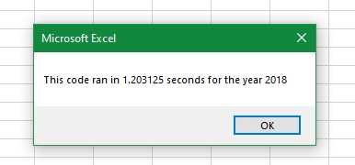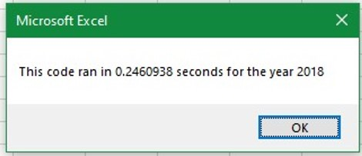

**Before and after refactoring of stock data 2018**

After refactoring

Before refactoring